Milestone 3 Design Phase

Student Patrol

Josh Caroon, Isaiah Oliver, Alex Howard, Haley Sarter



**Executive Summary** 3

**Non-Functional Requirements**3

**Hardware/Software Specifications**3

**Pseudocode**4

Login Pseudocode: 4

Add Officer: 4

Edit Officer Account: 5

Delete Officer Account: 6

Submit availability: 6

Check availability: 6

Schedule Creation: 7

Add to schedule: 7

**Data Flow Diagram Level 0**8

**Data Flow Diagram Level 1: Manage Account**9

**Data Flow Diagram Level 1: Manage Work Schedule**9

**Entity Relationship Diagram**10

**Navigation Diagram**11

**Standard Naming Conventions**12

**Login Page**13

**Submit Availability**15

**Manage Page**16

**Manage Work Schedule**20

**Manage Account**26

**Milestone Evaluation Sheet**41

# 

# Executive Summary

The main objectives of the patrol unit are to provide escorts to students or faculty, secure academic buildings, test on-campus security blue lights weekly, and sustain a safe campus environment. The Student Patrol Unit is placed throughout all the university. Their presence can be noticed on the health science campus, athletic campus, and main campus

This deliverable consists of documentation that cover many components dealing with the development of our proposed system. In this deliverable there is the Nonfunctional requirements, Hardware/Software Specification, Pseudocode, Data Flow Diagrams, Entity Relationship Diagram, Navigation Diagram, Standard Naming Conventions, and Mock Ups.

# Non-Functional Requirements

For the non-functional requirements, we focused on the operational, performance, and availability of the system. On the operational end, the system should run on access and will be written in C# coding language. Secondly, the performance non-functional requirements consist of the system being able to save the user’s schedule information. Also, the system should support access of up to 30 officers. Lastly, the systems availability; the system should lock out all user from requesting off after 5pm eastern standard time and should lock out all users from submitting their availability for the upcoming month on the 25th of each month. In conjunction with the listed non-functional requirements, the system should be available 24/7.

# Hardware/Software Specifications

Our proposed system is a browser based portal that utilizes any supported browser on either a handheld device or computer. Computer devices must run on the Mac or Windows operating systems and the handheld devices must run android or IOS operating systems. On the hardware end, there should be a central computer with a two-terabyte hard drive, 16 gigabytes of DDR4 RAM, an intel i7 7700k processor, with a compatible motherboard and dedicated network card that will run the database for storage.

# 

# Pseudocode

## Login Pseudocode:

Get PatrolID from User, check if valid

If valid then move to next step

Else prompt user to re-enter

Get Password from User, check if valid

If valid then move to next step

Else prompt user to re-enter

If conditions are met authenticate to database, check if valid

If valid then move to homepage

Else prompt user to re-enter PatrolID and password

## Add Officer:

User types PatrolID, check if valid

If valid move to next step

Else prompt user to re-enter

User types first name, check if valid

If valid move to next step

Else prompt user to re-enter

User types last name, check if valid

If valid move to next step

Else prompt user to re-enter

User types Password, check if valid

If valid move to next step

Else prompt user to re-enter

User types Email, check if valid

If valid move to next step

Else prompt user to re-enter

User selects Position, check if valid

If valid move to next step

Else prompt user to select

User selects Squad via dropdown, check if valid

If valid move to next step

Else prompt user to re-enter

User save new user

Window prompts user for confirmation

If user hits yes then send to data storage

Else return to edit screen with populated form

## Edit Officer Account:

User selects officer from dropdown

If user selected then populate form

Else return to edit screen

User makes edit to form

* First Name

If valid move to next step

Else prompt user to re-enter

* Last Name

If valid move to next step

Else prompt user to re-enter

* Email

If valid move to next step

Else prompt user to re-enter

* Password

If valid move to next step

Else prompt user to re-enter

* Position

If valid move to next step

Else prompt user to re-enter

* Squad

If valid move to next step

Else prompt user to re-enter

User click submit button

Prompt user with confirmation window

If user hits yes then send to data storage

Else return to edit screen with populated form

## Delete Officer Account:

User selects officer from dropdown

If user selected then populate form

Else return to edit screen

User click delete button

Prompt user with confirmation window

If user clicks check box then;

User hits yes then remove from data storage

Else return to edit screen with populated form

## Submit availability:

User selects upcoming work month

Radio button populate dates based upon the specified month based on sysdate

If user selects the yes radio button then the corresponding day on the calendar will turn green

Else user selects the no radio button then the corresponding day on the calendar will turn red

User click submit button

Prompt user with confirmation window

If user hits yes then send to data storage

Else return to populated radio buttons

## Check availability:

If Month = Current Month

And Date = 25

And Time = 5:00PM (Eastern Time)

Then Radio button = Hidden and/or grey overlay

And user is prompted with a message that states “Availability submission for this month is now closed, if possible, submit availability for next work month”

User is prompted with upcoming work month,

If user selects a work day

Then the user is prompted with the list of available officers for that day

Else the user is returned to the upcoming work month

## Schedule Creation:

User clicks the specific workday from their choice of month

User is prompted with populated workday window

User clicks slider button to signify their availability for that day

If user slides button to the left then the user is removed from the schedule that workday

Else the user stays on the list of working officers

## Add to schedule:

User clicks the specific workday from their choice of month

User is prompted with populated workday window

User clicks “Add Officer” button

Dropdown box takes the place of the “Add Officer” button

If user selected then add them to the schedule for that day

Else return to add officer button

# Data Flow Diagram Level 0

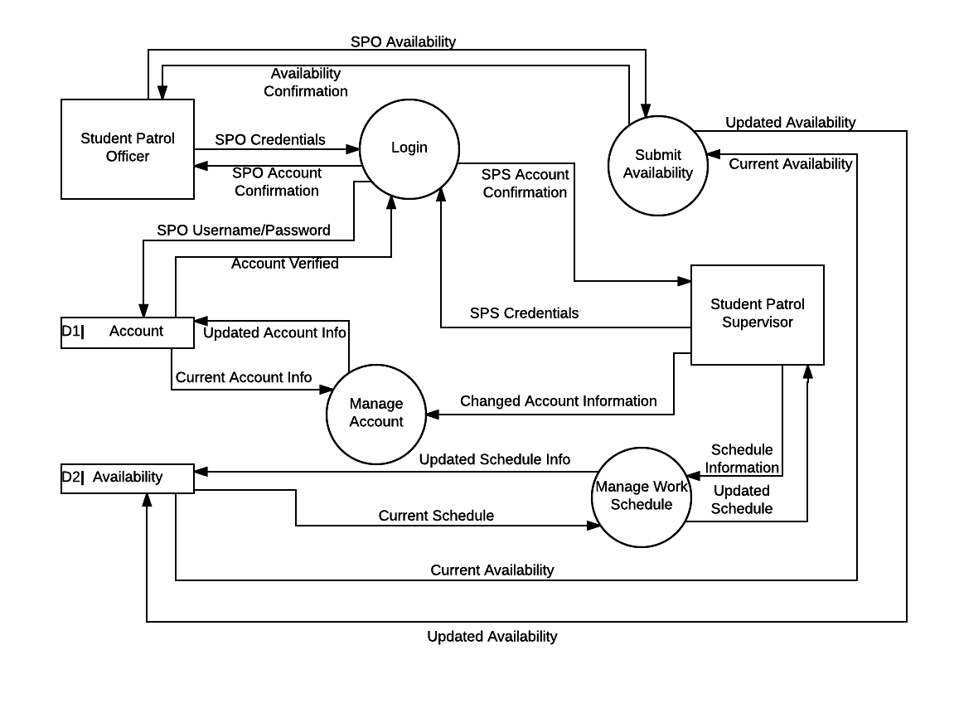

# Data Flow Diagram Level 1: Manage Account

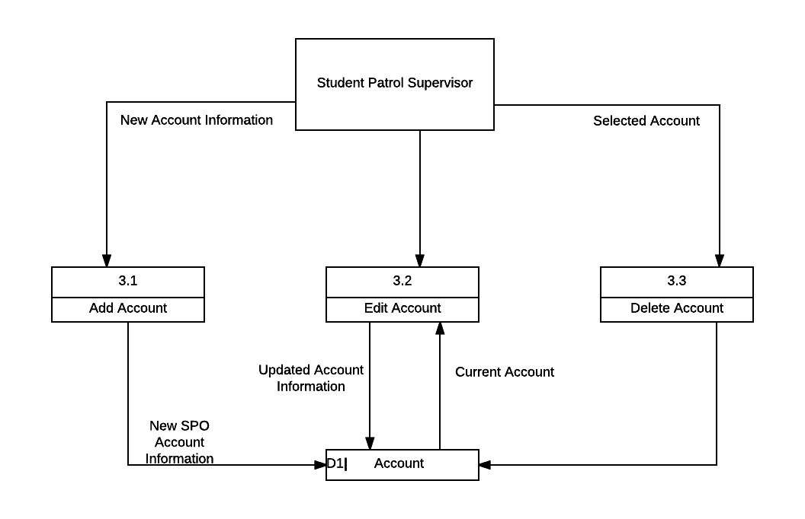

# Data Flow Diagram Level 1: Manage Work Schedule

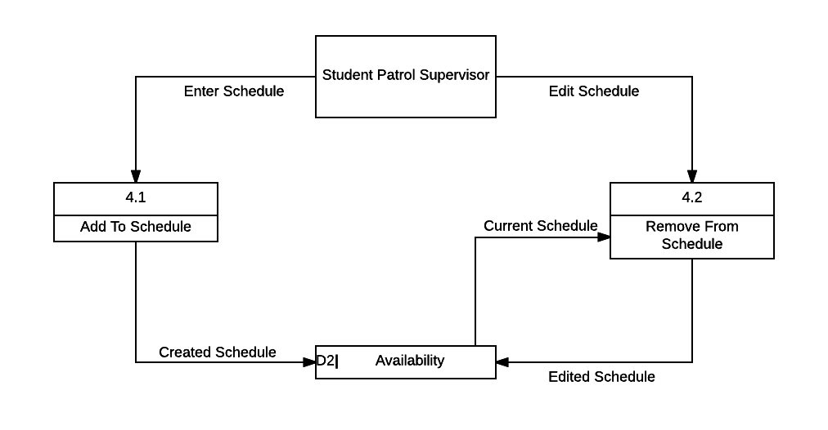

# 

# 

# Entity Relationship Diagram

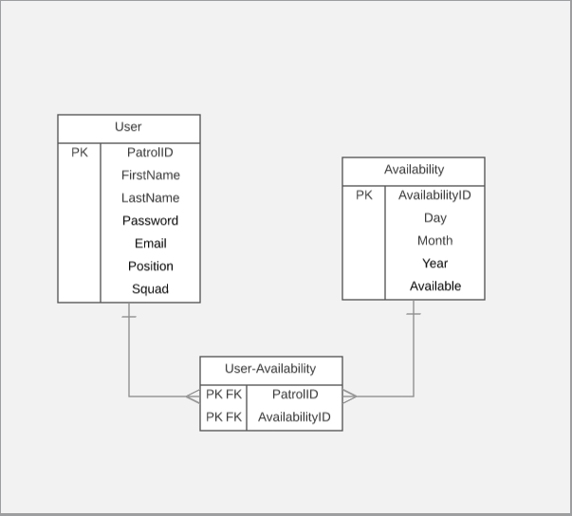

# 

# Navigation Diagram

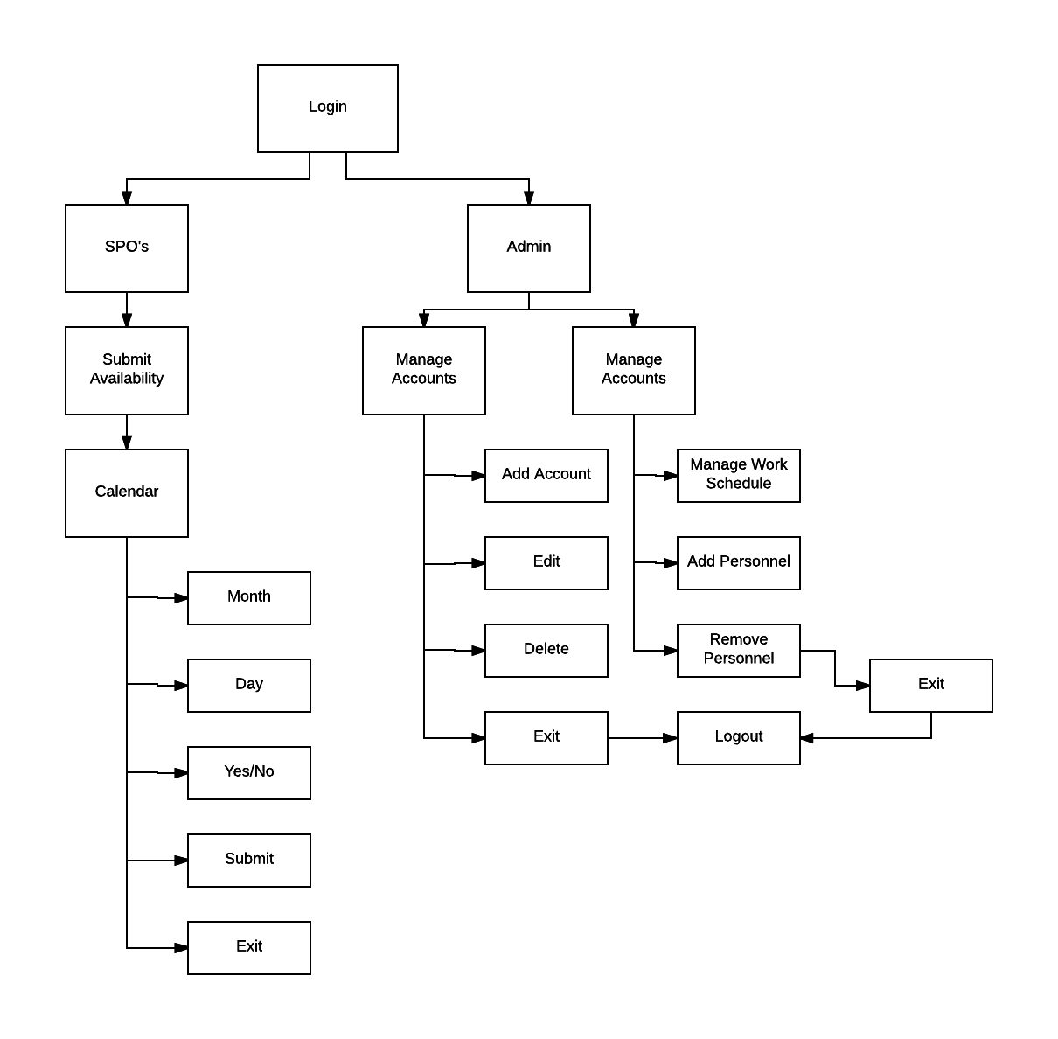

# Standard Naming Conventions

File names:  
First word lowercased + all other words uppercased with file type  
Examples: manageAccount.cs, editAccount.cs, loginPage.cs

Variables:  
First word lowercased + all other words uppercased  
Example: firstName, lastName, emailAddress, patrolID

# 

# Login Page

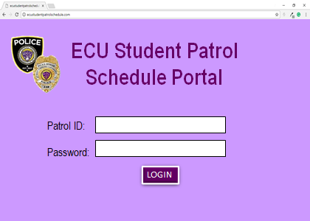

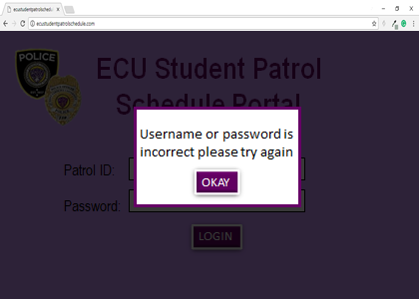

# Submit Availability

# Manage Page

# Manage Work Schedule

# 

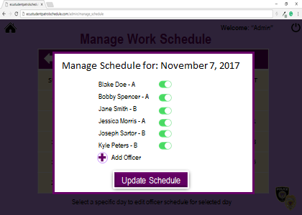

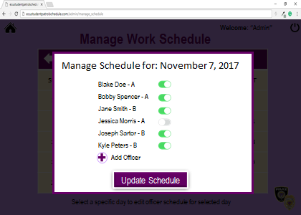

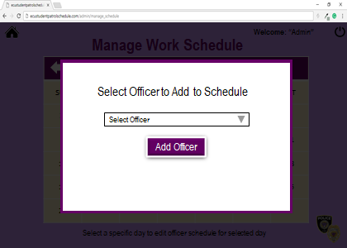

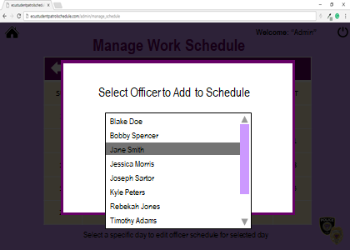

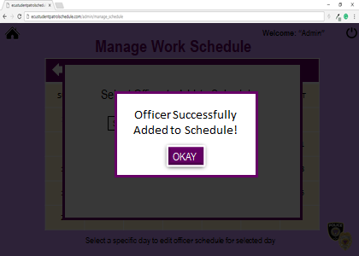

# Manage Account

# 

Add Account

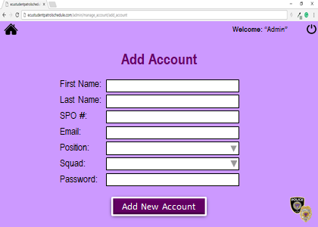

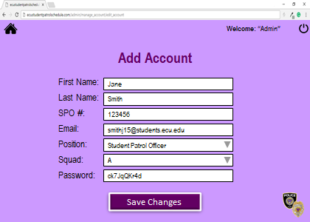

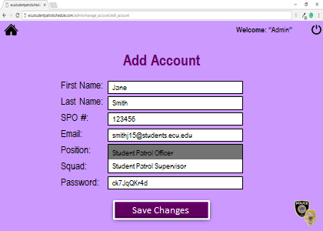

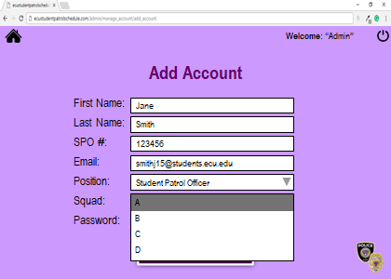



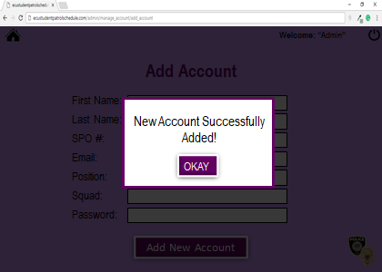

Edit Account

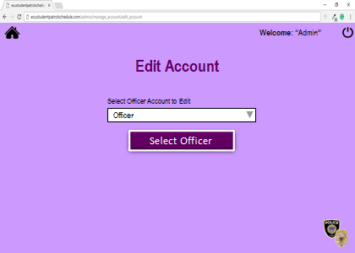

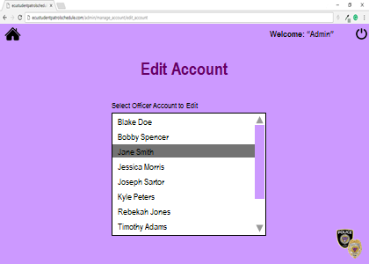

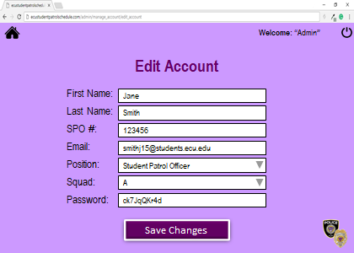

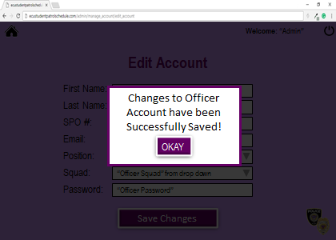

Delete Account

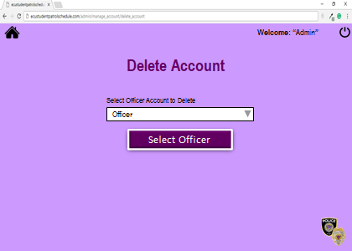

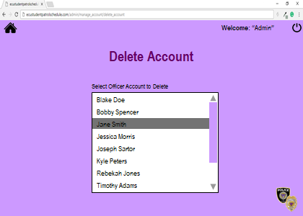

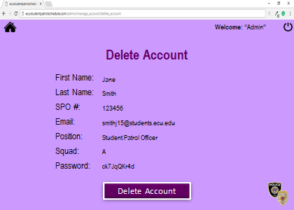

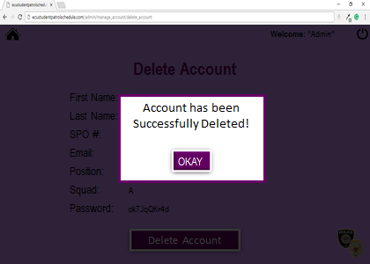

# Milestone Evaluation Sheet

**Milestone:** 3

**Type:** Design

**Due Date:** 10/23/17

**Progress and Accomplishments:**

For this Milestone, the group did a fantastic job of getting all of the work done. We have planned accordingly to the due date and delegated work for this weekend as to finish up the rest of what needs to be done for the presentation on Monday. We have not been behind at all.

**Problems Encountered:**

We have not had any problems in Milestone 3. As said above the group has done phenomenally well working with each other. The problem from Milestone 2 where the due date came quickly on us did not happen here.

**Progress Against Schedule:**

**Schedule:** On track to completing this Milestone. Each day this week we have met at least 1 hour to work on this project. We have been diligent, and everyone showed up being determined to complete this project.

**Activities for the Coming Milestone:**

**Milestone 4**

**● Type-** Structured Walkthrough

**● Due Date-** 11/01/17

* Database Development
* Program Development
* Test Plan
* Updated Project Plan
* Timesheets
* Milestone Evaluation